**FLOW CHART & THE PROCESS**

**1) Client Login.**

* **Step 1:** Client logs into the data analysis website.

**2)** **Input Excel Data.**

* **Step 2:** Client uploads or inputs an Excel data file.

**3) Data Processing (Backend, Hidden from Client).**

* **Step 3:** The uploaded Excel file is sent to the backend server.
* **Step 4:** Python script reads and processes the data.
* **Step 5:** Python script generates a Power BI dashboard automatically based on the processed data.

**4) Dashboard Generation.**

* **Step 6:** The generated Power BI dashboard is prepared.

**5) Client Views Dashboard.**

* **Step 7:** The client views and interacts with the Power BI dashboard on the website

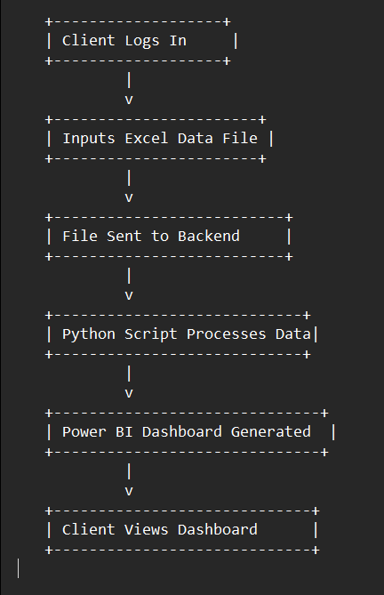

PowerBI_Dashboard_Generator/

│

├── app.py Your Flask application

├── generate_dashboard.py Your Power BI dashboard generation logic

├── uploads/ Directory to store uploaded files

└── output/ Directory to store generated dashboards (create

this if needed)